**Lingfield Primary School**

A Personal Best School



**Behaviour Policy**

|  |  |
| --- | --- |
| Date Agreed by Governors | Summer 2023 |
| Review Date | Summer 2024 |

**“Good behaviour in schools is central to a good education.”**

[*Behaviour in schools: advice for headteachers and school staff 2022*](https://www.gov.uk/government/publications/behaviour-in-schools--2)

**Contents**

|  |  |
| --- | --- |
| Policy Aims & Purpose | Underpinning Principles  Personal best school  Vision  Mission: Aims and Values  Pupil expectations  Culture Deck |
| Legislation, statutory requirements and statutory guidance |  |
| Leadership and Management - Roles and Responsibilities | The Role of the Governing Body  The Role of School Leaders  The Role of the DSL  The Role of teachers and staff  The Role of parents and carers  The Role of parents  The Role of children  Safeguarding |
| School Behaviour Curriculum | Classroom management  Whole School routines  Supervision routines -Breaks and Lunchtimes  Classroom routines  Environmental routines  Scripted responses |
| Inclusion | The graduated approach  SEND and SEMH  Thrive  Unidentified SEND  EHCPs  Transition |
| School Systems and Social Norms | Rules  Responding to good behaviour  Responding to poor behaviour  Rupture and Repair  Low-level behaviour  Consequences for low-level behaviour  The de-escalation approach  Serious Behaviour  Consequences for serious behaviour  Bullying  Formal Logs  Sexualised behaviour  Prejudice-related incidents  Safe touch  Off-site behaviour  Online behaviour  Mobile phones |

# 

# Policy Aims & Purpose

This policy aims to:

* Underpin behaviour in school reflecting the core values of respect, resilience and relationships
* Create a calm, safe and supportive environment where children can learn effectively
* Establish a whole-school approach to maintaining high standards of behaviour which reflect the values of the school
* Outline the expectations and consequences of behaviour, including bullying and different forms of discrimination
* Provide a consistent approach to the behaviour curriculum that is applied to all children based on their circumstances and needs
* Provide children with an understanding of emotional regulation and strategies to manage dysregulation

# Reflect the school’s drive to embrace diversity and foster tolerance

# Purpose

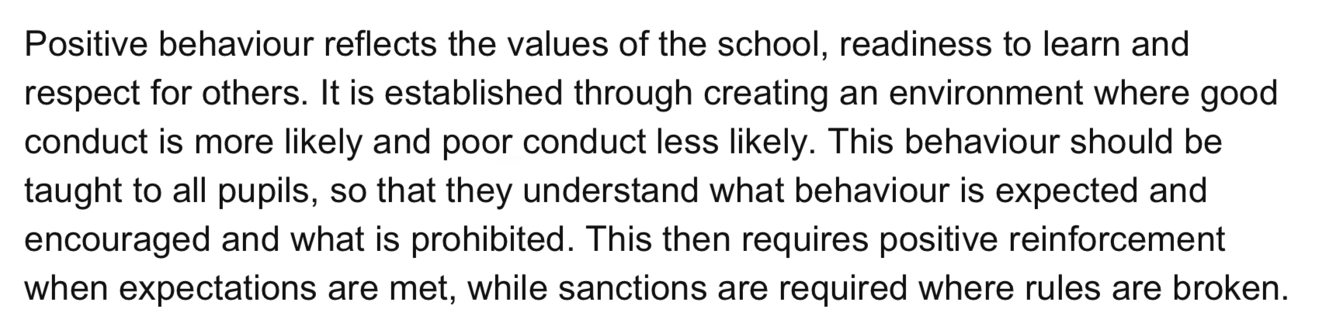

*Behaviour in schools: advice for headteachers and school staff 2022*

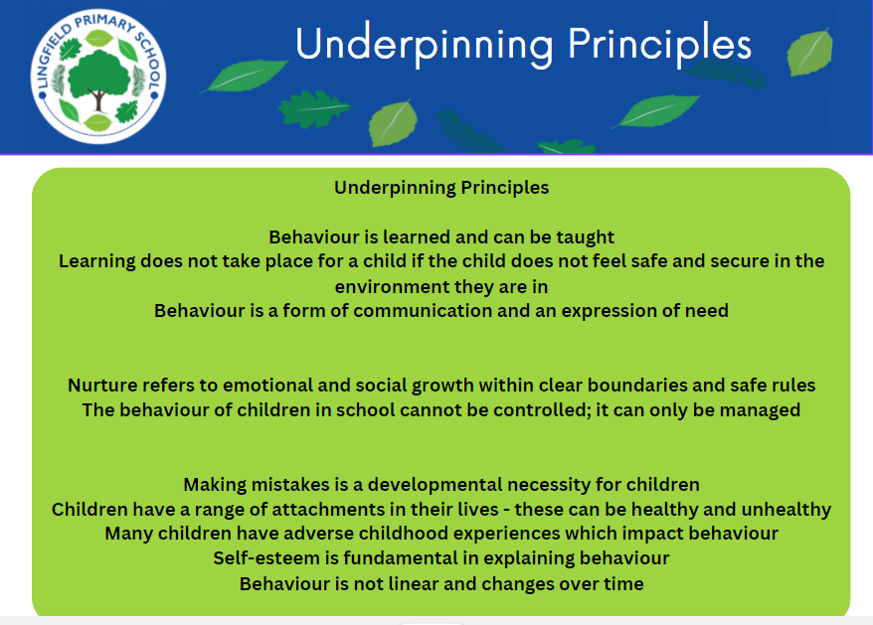

Lingfield Primary School is a **Personal Best School.**

The approach to behaviour at the school is underpinned by the core values of: **Respect, Resilience and Relationships.**

Behaviour is integrated into the **Vision**, **Aims and Values**, **Culture Deck** and **Inclusion Policy** of the school.

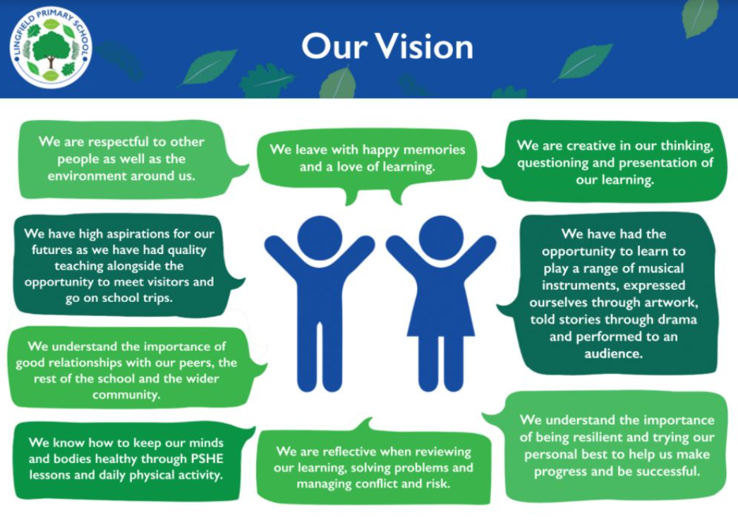

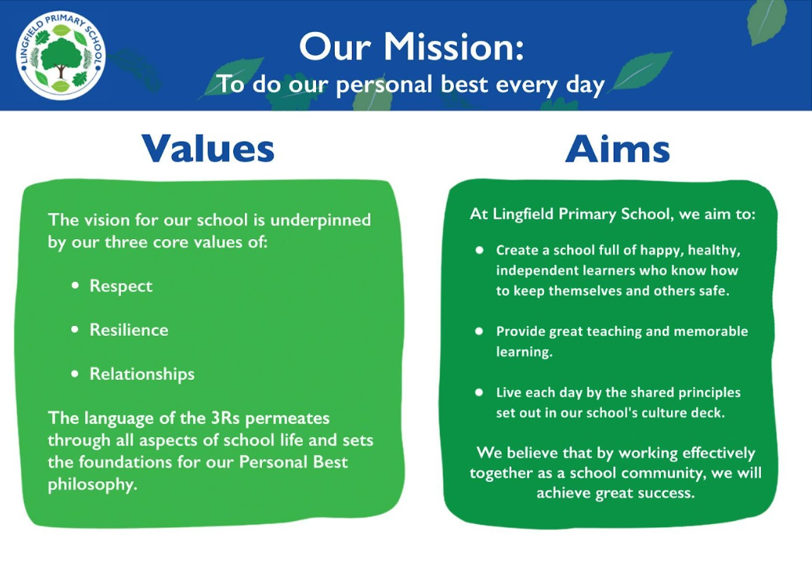

**Pupil Expectations**

* Engage in learning and strive to do their personal best
* Set a positive example to others around the school, including outside on paths and the playground
* Treat others with empathy and respect
* Understand that being safe is everyone’s responsibility
* Follow instructions
* Use appropriate language
* Use learnt strategies to help with emotional dysregulation
* Talk to trusted adults - class teacher, teaching assistant, DSL, HT, SENCO, etc - if upset or concerned
* Understand that their behaviour reflects the ethos of the school
* Be respectful working with others
* Wear correct uniform and maintain good personal hygiene

Where appropriate and reasonable, adjustments may be made to routines within the curriculum to ensure all children can meet behavioural expectations in the curriculum.

# 

# 

# 

# 

# 

# 

# 

# Legislation, Statutory Requirements and Statutory Guidance

**This policy is based on legislation and advice from the Department for Education (DfE) on:**

* [Behaviour and discipline in schools: advice for headteachers and school staff, 2016](https://www.gov.uk/government/publications/behaviour-in-schools--2)
* [Behaviour in schools: advice for headteachers and school staff 2022](https://www.gov.uk/government/publications/behaviour-in-schools--2)

* [The Equality Act 2010](https://www.gov.uk/government/publications/equality-act-2010-advice-for-schools)

* [Keeping Children Safe in Education](https://www.gov.uk/government/publications/keeping-children-safe-in-education--2) 2022

* [Suspension and permanent exclusion from maintained schools, academies and child referral units in England, including child movement - 2022](https://www.gov.uk/government/publications/school-exclusion#:~:text=Schools%20and%20colleges%20must%20continue,headteachers)

* [Use of reasonable force in schools 2013](https://www.gov.uk/government/publications/use-of-reasonable-force-in-schools)

* [Special Educational Needs and Disability (SEND) Code of Practice](https://www.gov.uk/government/publications/send-code-of-practice-0-to-25).

# 

# 

# 

# 

# 

# 

# 

# 

# 

# 

# 

# 

# 

# 

# 

# 

# 

# 

**Leadership and Management - Roles and responsibilities**

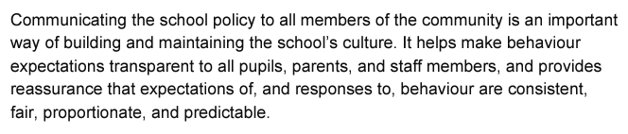

*Behaviour in schools: advice for headteachers and school staff 2022*

**The role of the Governing Board**

The Governors are responsible for:

* Reviewing and approving the written statement of behaviour principles and the behaviour policy
* Monitoring the policy’s effectiveness
* Holding the headteacher to account for its implementation

**The role of the school leaders**

The headteacher is responsible for:

* Approving and reviewing this policy in conjunction with the governors
* Ensuring that the school environment encourages positive behaviour
* Monitoring that the policy is consistently implemented by staff with all groups of children
* Evaluate the effectiveness of the school’s approach to managing behaviour

**The role of the DSL**

The DSL is responsible for:

* Providing new staff with a clear induction into the school’s behavioural culture to ensure they understand its rules and routines, and how best to support all children to participate fully
* Offering appropriate training in behaviour management, and the impact of special educational needs and disabilities (SEND) and mental health needs on behaviour to any staff who require it so they can fulfil their duties set out in this policy
* Ensuring this policy works alongside the safeguarding policy to offer children both consequences and support when necessary, using data from behaviour logs to make sure that no groups of children are being disproportionately impacted by this policy

**The role of teachers and staff**

Staff are responsible for:

* Establish a safe and stimulating environment for pupils, rooted in mutual respect
* Demonstrate consistently the positive attitudes, values and behaviour which are expected of pupils
* Have a secure understanding of how a range of factors can inhibit pupils’ ability to learn, and how best to overcome these
* Have clear rules and routines for behaviour in classrooms, and take responsibility for promoting good and courteous behaviour both in classrooms and around the school, in accordance with the school’s behaviour policy
* Have high expectations of behaviour, and establish a framework for discipline with a range of strategies, using praise, sanctions and rewards consistently and fairly
* Manage classes effectively, using approaches which are appropriate to pupils’ needs in order to involve and motivate them
* Maintain good relationships with pupils, exercise appropriate authority, and act decisively when necessary.
* Record behaviour incidents promptly (via CPOMs)
* Encourage pupils to take a responsible and conscientious attitude to their own work and study

**The role of parents and carers**

The school will endeavour to build a positive relationship with parents and carers by keeping them informed about developments in their child's behaviour and the school’s policy, and working in collaboration with them to support any behavioural issues.

[Home School Agreement](https://docs.google.com/document/d/1wNwM8myh0hyk_dujlQOLYwPRtgnGlEuU1XcUXTEvVUc/edit?usp=drive_link)

**The role of children**

Children are expected to follow the school rules and to exhibit behaviour that models the core values of respect, resilience and relations. Some children will struggle to understand and/or follow these rules and so an adapted behaviour curriculum may be necessary which is discussed with parents/carers and planned for in conjunction with the Leadership Team.

**Safeguarding**

The school recognises that changes in behaviour may be an indicator that a child is in need of support, help or protection.

We will consider whether a child’s poor behaviour may be linked to them suffering, or being likely to suffer, significant harm.

Where this may be the case, we will follow our child protection and safeguarding policy, and consider whether pastoral support, an early help intervention or a referral to child’s social care is appropriate.

[Child Protection and Safeguarding Policy 2023.docx](https://docs.google.com/document/d/1WdDmRuFDHT4mcrrQJAQfPWc_43MkABfN/edit?usp=drive_link&ouid=105553177631545369780&rtpof=true&sd=true)

# 

# 

# 

# 

# School Behaviour Curriculum

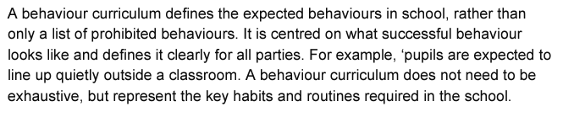

[*Behaviour in schools: advice for headteachers and school staff 2022*](https://www.gov.uk/government/publications/behaviour-in-schools--2)

**Classroom management**

Everyone is responsible for setting the tone and context for positive behaviour within the school.

Children will be taught how to identify success and to develop positive self-esteem. Teachers will have specific planned strategies to allow children to reflect on their learning - both academic and social - and to communicate this with parents/carers.

They will:

* Create and maintain a stimulating environment that encourages children to be engaged
* Display the school rules
* Develop a positive relationship with children, which will include:
  + Greeting children in the morning/at the start of lessons
  + Establishing clear routines
  + Communicating expectations of behaviour in ways other than verbally
  + Highlighting and promoting good behaviour
  + Concluding the day positively and starting the next day afresh
  + Brain Breaks during the school day to provide children with regulation opportunities
  + Having a plan for dealing with disruption
  + Using positive reinforcement
  + If disruption to the class is excessive, classroom teachers can call upon the Leadership Team to support them

**Whole school routines**

Routines to ensure safe and calm behaviour around the school building

[**Whole school routines**](https://docs.google.com/document/d/1ZCqahXaOUeg9CM7ga0f0gUtPZkLcz863ydf5_WjGKhQ/edit?usp=drive_link)

**Supervision routines - Breaks and Lunchtimes**

Routines to ensure safe and calm behaviour at break and lunch

[Supervision routines - Breaks and Lunchtimes](https://docs.google.com/document/d/1sNV7EVohgPGjr-7KJH2IYgbuQbNDnN2B7Y0cQicQrqM/edit?usp=drive_link)

**Classroom routines**

Routines to ensure consistent and learnt behaviour in the classroom

[Classroom routines](https://docs.google.com/document/d/1bgnmmsSkIaf6eMKvNHlQcsjgJpx_ZSNR3obWw_De9yM/edit?usp=drive_link)

**Environmental routines**

Routines to ensure organised and tidy learning areas

[Environmental routines](https://docs.google.com/document/d/1u9Nkc8EkKhJ5IR3fe_XvaRHSziThh9f3dGYZ4f-9LVI/edit?usp=drive_link)

**Scripted Responses**

The school uses scripted responses in a range of situations to ensure consistency of language, expectation and consequence. Scripted responses fall within the following categories:

* Classroom and Learning
* Behaviour
* Friendships
* Disclosure
* Parental request

[Scripted Responses - Common Questions](https://docs.google.com/document/d/1-LqSOny8I4FPR8uJ96jQCXOueeFXGXD1FTewVaiIyew/edit?usp=sharing)



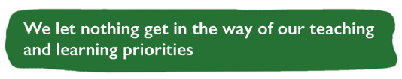

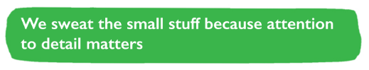

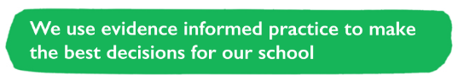

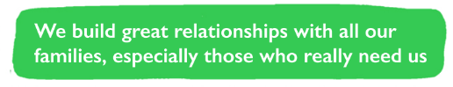

**Inclusion**

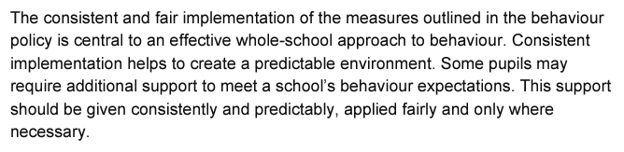

*Behaviour in schools: advice for headteachers and school staff 2022*

**The graduated approach**

[Surrey's Graduated Response document](https://www.surreylocaloffer.org.uk/__data/assets/pdf_file/0003/280767/GRADUATED-RESPONSE-Early-Years-Sep-22.pdf) aims to provide clear and consistent guidance about assessing, planning, carrying out and reviewing support and intervention for children with SEND - this directly involves many children with challenging behaviours.

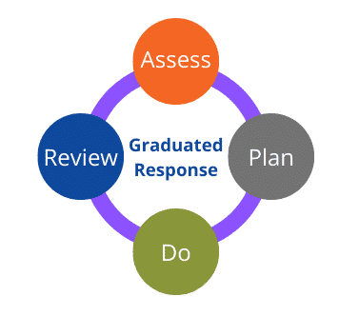

**SEND and SEMH**

The school recognises that children’s behaviour may be impacted by a special educational need or disability (SEND). The school also recognised that some children may have a specific emotional trauma in their childhood that may impact their behaviour - this is social, emotional and mental health (SEMH) which is part of SEND.

[SEND Policy and Information Report.docx](https://docs.google.com/document/d/1UW7hLZw3ti4h5mtUrXAHcW5os-bKHRTv/edit?usp=drive_link&ouid=105553177631545369780&rtpof=true&sd=true)

When incidents of poor behaviour arise, we will consider them in relation to a child’s SEND, although we recognise that not every incident of poor behaviour will be connected to their SEND. Decisions on whether a child’s SEND had an impact on an incident of poor behaviour will be made on a case-by-case basis.

When dealing with poor behaviour from children with SEND, especially where their SEND affects their behaviour, the school will balance their legal duties when making decisions about enforcing the behaviour policy. The legal duties include:

* Taking reasonable steps to avoid causing any substantial disadvantage to a disabled child caused by the school’s policies or practices ([Equality Act 2010](https://www.gov.uk/government/publications/equality-act-2010-advice-for-schools))
* Using our best endeavours to meet the needs of children with SEND ([Children and Families Act 2014](https://www.legislation.gov.uk/ukpga/2014/6/contents/enacted))
* If a child has an education, health and care (EHC) plan, the provisions set out in that plan must be secured and the school must cooperate with the local authority and other bodies

As part of meeting these duties, the school will anticipate, as far as possible, all likely triggers of poor behaviour and put in place support to prevent these from occurring.

Any preventative measures will take into account the specific circumstances and requirements of the child concerned.

This approach may include examples such as:

* Short, planned movement breaks for a child with SEND who finds it difficult to sit still for long
* Adjusting seating plans to allow a child with visual or hearing impairment to sit in sight of the teacher
* Adjusting uniform requirements for a child with sensory issues or who has severe eczema
* Training for staff in understanding conditions such as autism, ADHD, ASD
* Use of separation spaces (such as the THRIVE room) where children can regulate their emotions during a moment of sensory overload
* Responsible adult accompaniment on school trips

When considering a behavioural consequence for a child with SEND, the school will take into account:

* Whether the child was unable to understand the rule or instruction?
* Whether the child was unable to act differently at the time as a result of their SEND?
* Whether the child is likely to behave aggressively due to their particular SEND?

The school will then assess if it is appropriate to use a consequence and if so, whether any reasonable adjustments need to be made to the consequence. In severe circumstances suspension will be considered.

**Thrive**

Thrive provides a whole-setting approach to supporting the right-time social and emotional development of all children and young people, enabling them to feel safe, supported and ready to learn. The Thrive Approach consists of web-based profiling, action-planning and progress monitoring tools, enabling the best outcome for each child or group, and the wider impact of interaction based on the emotional needs of different age groups, informed by established neuroscience and attachment research, as well as child development studies and research into risk and resilience factors.

As part of the wider THRIVE programme, children will be taught about emotional regulation and how the human brain works. Every year-group will be taught how to self-regulate if required. Zones of regulation are used to identify emotional states.

**Unidentified SEND**

The SENCO may evaluate a child who exhibits challenging behaviour to determine whether they have any underlying needs that are not currently being met.

Where necessary, support and advice will also be sought from specialist teachers, an educational psychologist, medical practitioners and/or others, to identify or support specific needs.

When acute needs are identified in a child, we will liaise with external agencies and plan support programmes for that child. We will work with parents to create the plan and review it on a regular basis.

**Education, Health and Care Plan (EHCP)**

The provisions set out in the EHCP must be secured and the school will cooperate with the local authority and other bodies.

If the school has a concern about the behaviour of a child with an EHCP, it will make contact with the local authority to discuss the issue. If appropriate, the school may request an emergency review of the EHCP.

# Transition

# The school will support incoming children and their families to meet behaviour standards by offering an induction process to familiarise them with the behaviour policy and the wider school culture.

To ensure a smooth transition to the next year, children have transition sessions with their new teacher. In addition, staff members hold transition meetings to ensure rigorous handover of information.

To ensure behaviour is continually monitored and the right support is in place, information related to child behaviour issues may be transferred to relevant staff at the start of the term or year.

# School Systems and Social Norms

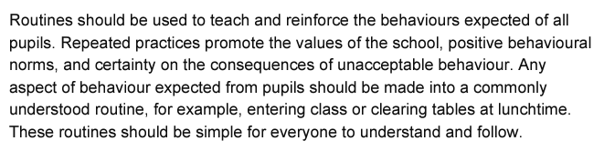

*Behaviour in schools: advice for headteachers and school staff 2022*

# Rules

Children are expected to:

* Engage in learning and strive to do their personal best
* Set a positive example to others around the school, including outside on paths and the playground
* Treat others with empathy and respect
* Understand that being safe is everyone’s responsibility
* Follow instructions
* Use appropriate language
* Use learnt strategies to help with emotional dysregulation
* Talk to trusted adults if upset or concerned
* Understand that their behaviour reflects the ethos of the school
* Be respectful working with others
* Wear correct uniform and maintain good personal hygiene

**Responding to good behaviour**

When a child’s behaviour goes above and beyond the expected behaviour standard, staff will recognise it with positive recognition and reward. This provides an opportunity for all staff to reinforce the school’s culture and ethos.

Positive reinforcements and rewards will be applied clearly and fairly to reinforce the routines, expectations and norms of the school’s behaviour culture.

Positive behaviour may be rewarded with:

* Dojos being given to individuals or groups with clear rewards for dojos
* Verbal praise
* Communicating praise to parents/carers via a phone call or written correspondence
* Positions of responsibility, such as school council or, in the case of older child, leader roles in the school
* Whole-class, year group or house rewards, such as extra break times, star of the week, raffle winner

Some children will have a differentiated reward system. Individual needs are taken into account and personalised incentives may be necessary for specific children .

**Responding to poor behaviour**

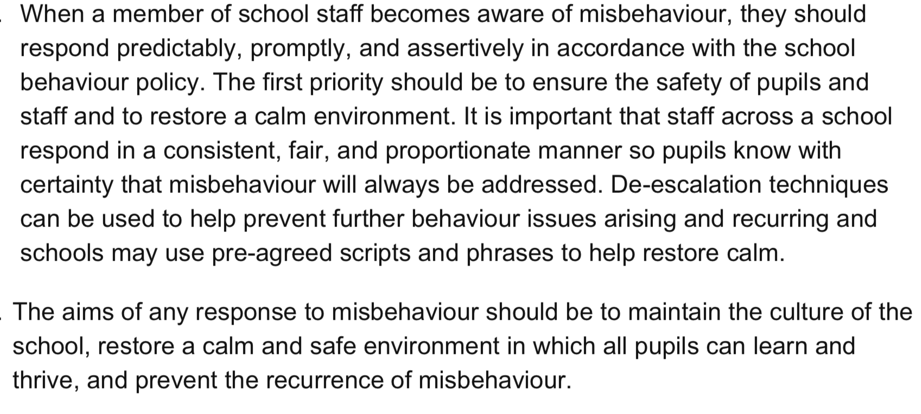

*Behaviour in schools: advice for headteachers and school staff 2022*

As a school, we understand that learning is an ongoing process and that mistakes are an inevitable part of this journey. Mistakes are part of the learning experience that enable children to develop, grow and understand risk.

When a child’s behaviour falls below the standard that can reasonably be expected of them, staff will respond in order to restore a calm and safe learning environment, and to prevent recurrence of unwanted behaviour.

All behavioural incidents are logged and recorded on CPOMS. Some children may have a personalised behaviour log as a short-term approach to identifying patterns in behaviour and supporting behavioural strategies.

Staff will endeavour to create a predictable environment by always challenging behaviour that falls short of the standards and by responding in a consistent, fair and proportionate manner, so children know with certainty that poor behaviour will always be addressed at a time that is appropriate to the individual.

De-escalation techniques will be used to help prevent further behaviour issues arising.

Poor behaviour can happen in school, out of school and online.

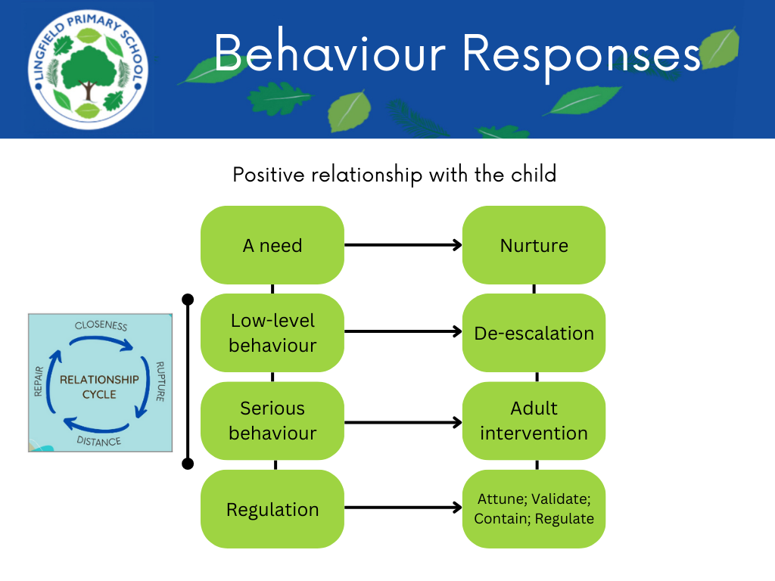

Any factors that contributed to the behavioural incident identified and considered.

# Rupture and Repair

Following a consequence, the school will consider strategies to help children to understand how to improve their behaviour and meet the expectations of the school. This is vital as part of the rupture/repair cycle.

This could include measures such as:

* Reintegration meetings
* Daily contact with a trusted adult in school
* Opportunities for restoration
* Identification of any SEND and/or SEMH needs

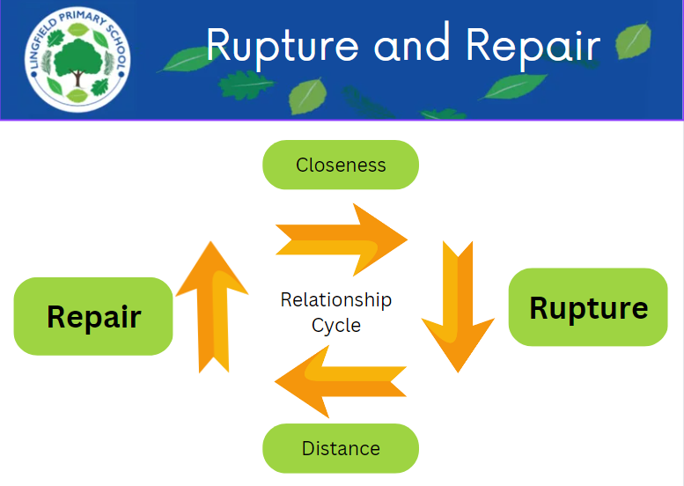

The rupture/repair cycle highlights how this shared regulation - the facing of a challenge together and modelled resilience - strengthens the relationship and teaches children that adversity can have an end point and to trust that this can happen. It is fundamentally linked to attachment theory and the principle that, through relationships with important attachment figures, children learn to trust others, regulate their emotions, and interact with the world. Children need to have this modelled before they can learn it themselves.

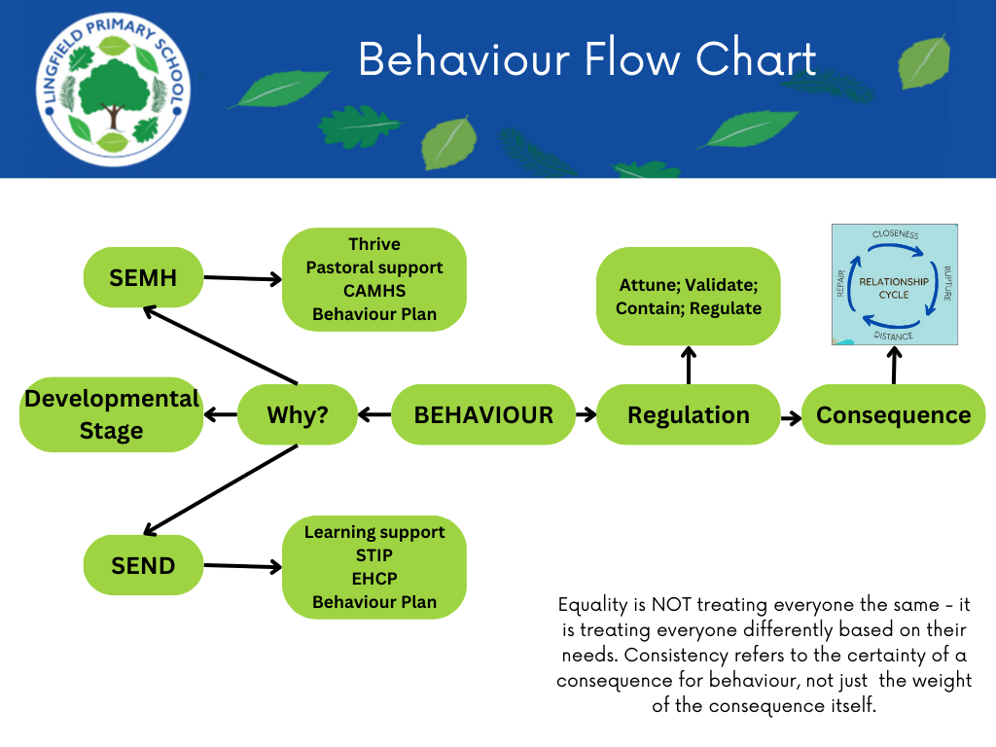

When dealing with the consequences of behaviour, staff will also consider what support could be offered to a child to help them to meet behaviour standards in the future

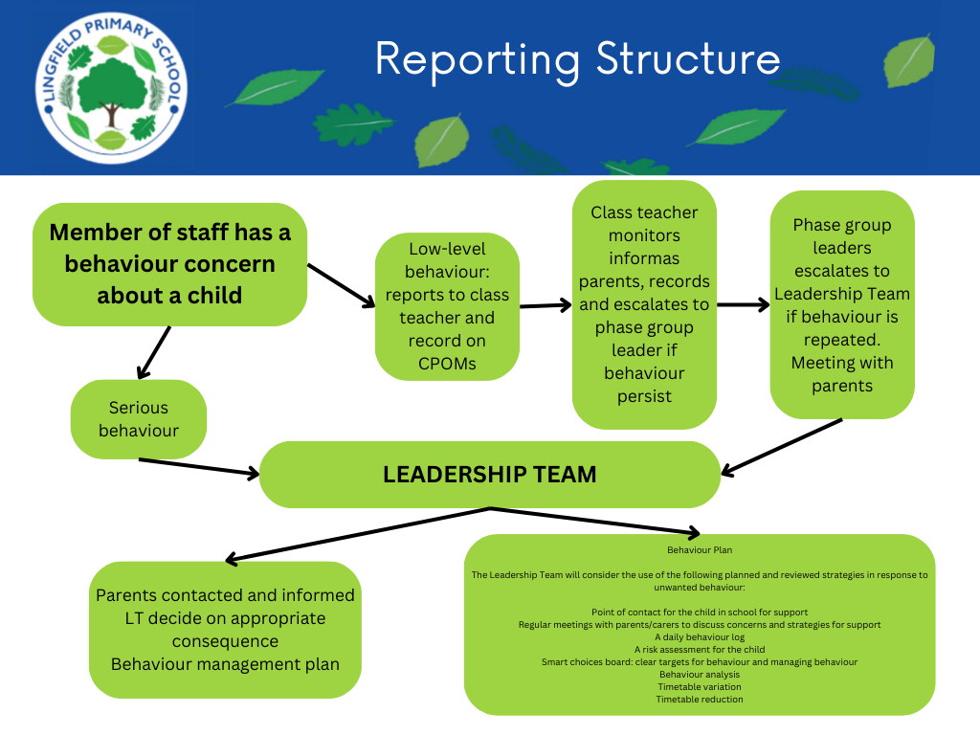

**Low-level behaviours**

**Low-level behaviours are defined as:**

* Distracting learning in lessons
* Disruption in the school building, at break or at lunchtimes
* Poor attitude
* Incorrect uniform

**Consequences for low-level behaviours**

Staff will use a variety of de-escalation and diffusion strategies to support children in school.

Staff may need to use one or more of the following consequences in response to unacceptable behaviour in the following circumstances:

|  |  |
| --- | --- |
| **Distracting learning in lessons**  Leaving seat in the classroom  Repeated behaviour that is impacting learning, e.g. calling out, laughing at others, fiddling | * Clear, verbal reminder of the expected behaviour * Removal to another class * Time spent away from year group (internal isolation) |
| **Disruption in the school building, at break or at lunchtimes**  Not following SSS moving around the school  Not following STEM in the dining hall  Constant friendship issues  Behaviour that may present harm to themselves and/or others  Failure to follow clear instructions  inappropriate language and/or gestures | * Sent back to walk/behave in the manner expected * Practice at break or lunchtime * Pastoral support offered * Removal to another class * Time spent away from year group (internal isolation) - learning set by the class teacher to be completed in the leadership offices |
| **Not achieving a personal best in learning** Change in behaviour without known context  Evidence of emotional dysregulation | * Opportunity to regulate alone or, if necessary, with an adult * Work to be completed at break or lunchtime * Work sent home to be completed with parent/carer |
| **Poor attitude**  Disrespectful behaviour, including answering back | * Opportunity to regulate alone or, if necessary, with an adult * Removal to another class * Time spent away from year group (internal isolation) |
| **Incorrect uniform**  Lack of uniform - presentation/hygiene | * Phone call home to parents/carers * Change into pre-loved clothing if appropriate |

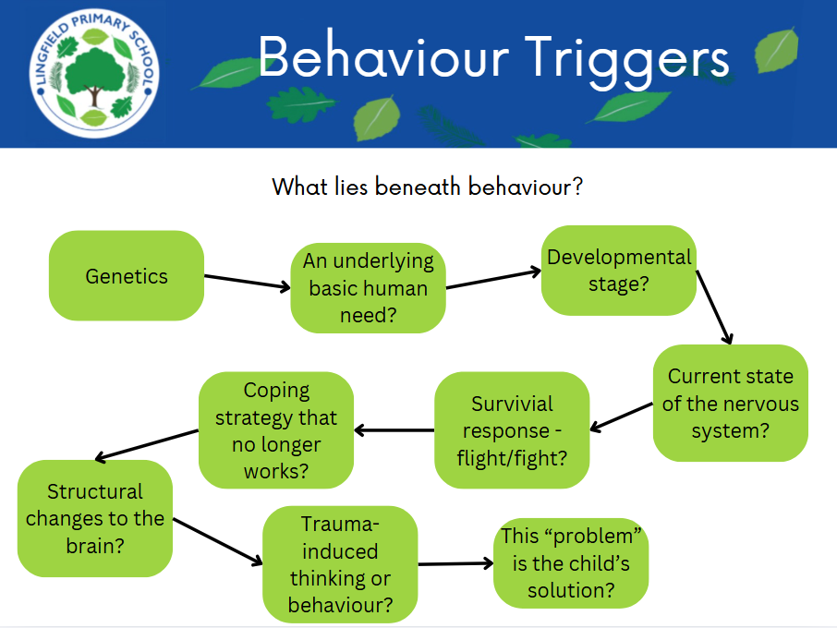

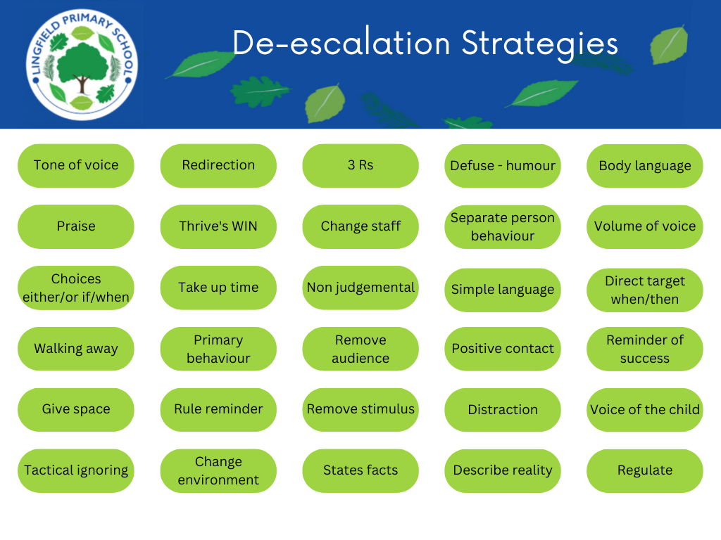

**De-escalation Approach**

Repeated low-level behaviours will be managed by an strategic approach that may include:

* Point of contact for the child in school for support
* Regular meetings with parents/carers to discuss concerns and strategies for support
* A daily behaviour log
* A risk assessment for the child
* Smart choices board: clear targets for behaviour and managing behaviour
* Behaviour analysis
* Timetable variation
* Timetable reduction

Dealing with a dysregulated child, we use the **THRIVE vital relational functions (VRFs):**

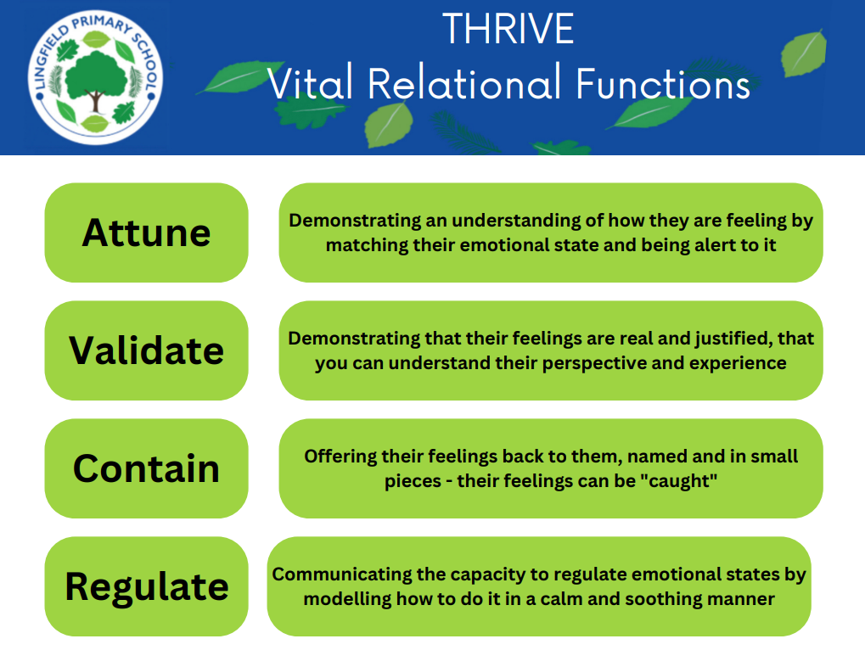

**Serious Behaviour**

**Serious behaviours are defined as:**

* Persistent disruptive behaviour
* Physical assault
* Verbal abuse/threatening behaviour
* Bullying **-** including homophobic abuse
* Racist abuse
* Abuse relating to disability
* Damage - property or possessions
* Sexual misconduct
* Inappropriate use of social media or online technology
* Drug and alcohol related
* Wilful and repeated transgression of protective measures in place to protect public health - these include suspected criminal behaviour. These are:
  + Theft
  + Offensive weapon
  + Knives or weapons, alcohol, illegal drugs, stolen items, tobacco and cigarette papers, fireworks, pornographic images or any article a staff member reasonably suspects has been, or is likely to be, used to commit an offence, or to cause personal injury to, or damage to the property of, any person (including the child)

**Consequences for serious behaviours**

The school may use one or more of the following consequences in response to unacceptable behaviour, at the discretion of the Headteacher or a member of the Leadership Team. Parents will be informed if a major concern is identified.

All serious behaviours are behaviours that can warrant a school suspension in certain circumstances.

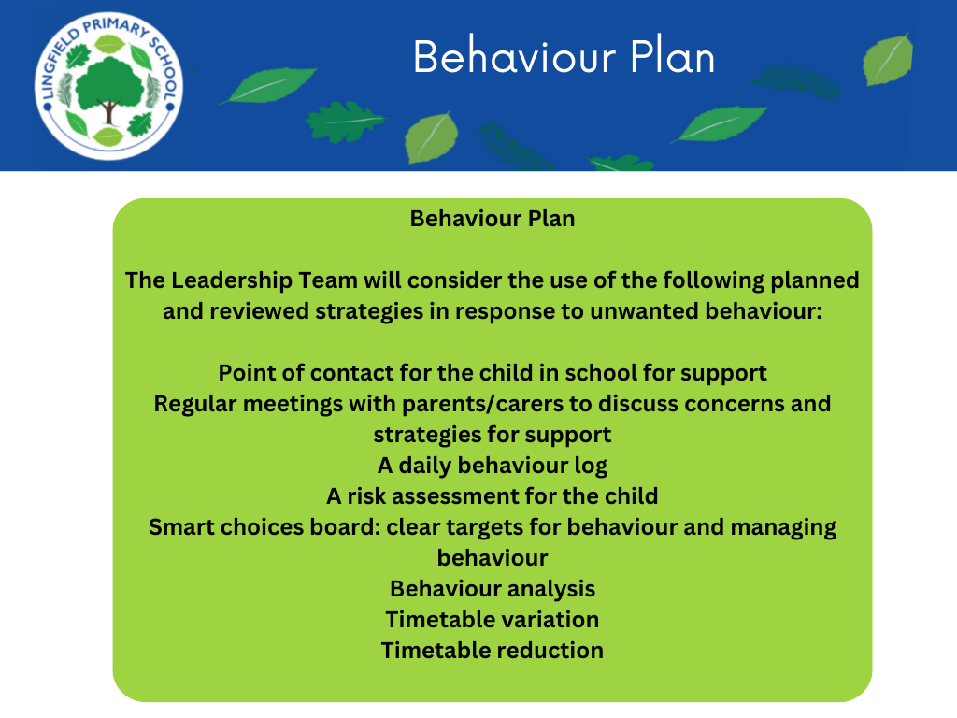

External agencies, including Surrey Police, Children’s Service, Prevent and County Lines, may be contacted if necessary. We will also confiscate any item that is harmful or detrimental to school discipline. These items will be returned after discussion with the Leadership Team and parents, if appropriate.

In the case of leaving the school premises, police contacted as per the [**Memorandum of Understanding (MoU)**](https://surreycountycouncil.newsweaver.co.uk/SchoolsBulletin/2wjew5z6fm5?a=6&p=53866898&t=20022805) with Surrey Police

[Memorandum of Understanding (MoU) with Surrey Police](https://docs.google.com/document/d/1wSYhTH5wz-m8UoCcvaU8VtjPz4lO_aZtmt5sNDfYzq4/edit?usp=drive_link)

Personal circumstances of the child will be taken into account when choosing consequences and decisions will be made on a case-by-case basis, but with regard to the impact on perceived fairness.

There may be times when a responsible adult is required to accompany a child on school trips - this will be discussed with parents/carers in advice of the trip.

# Bullying

“The repetitive, intentional hurting of one person or group by another person or group, where the relationship involves an imbalance of power. Bullying can be physical, verbal or psychological. It can happen face-to-face or online’”

*Anti-Bullying Alliance 2023*

Bullying is therefore:

* Deliberately hurtful
* Repeated, often over a period of time
* Difficult to defend against

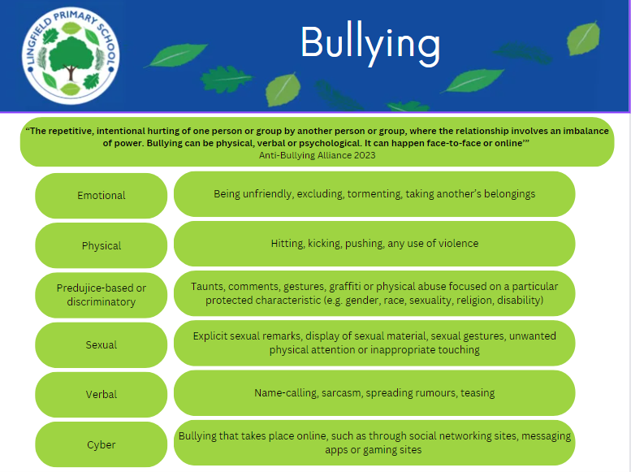

When bullying is alleged to have taken place, the DSL will investigate the allegations over a period of time. This investigation follows a structured format:

* Review of CPOMs entries for the specified individuals
* Conversations with the specified individuals to establish perception, interpretation of events, point of view and feelings
* Conversations with peers when appropriate, considering friendships and prior relationships with the specified individuals
* Conversations with professionals working with the specified individuals

A meeting will take place with the individuals involved for review of the investigation.

**Formal Logs**

The school records behavioural incidents using the following systems:

* CPOMs
* Internal Isolation Log
* Prejudice-Related Incidents Monitoring Form
* Sexualised Behaviour Log
* Restrictive Physical Intervention Log

**Sexualised behaviour**

The school will ensure that all incidents of sexual harassment and/or violence are met with a suitable consequence and are never ignored. Staff in school are trained to use the Brook Traffic Light Tool in identifying age-appropriate and concerning sexualised behaviour.

Children are encouraged to report anything that makes them uncomfortable, no matter how ‘small’ they feel it might be.

The school’s response will be:

* Proportionate
* Considered
* Supportive
* Decided on a case-by-case basis

The school has procedures in place to respond to any allegations or concerns regarding a child’s safety or wellbeing.

**Prejudice-related incidents**

In the case of sexual bullying, sexual violence or sexual harassment, the report will be recorded on the **Predujice-Related Incidents Monitoring Form** and fully investigated, and relevant outside agencies involved as appropriate. Risk assessments will also be completed following any reports of sexual violence (KCSiE, paragraph 444).

In the case of prejudiced behaviour, such as homophobia, xenophobia, transphobia, disability-targeted language, the incident is logged on the **Prejudice-Related Incidents Monitoring Form**.

**Safe touch**

Safe touch covers a range of interventions that involve physical contact with children. All members of staff have a duty to use reasonable force, in the following circumstances, to prevent a child from:

* Hurting themselves or others
* Damaging property
* Committing an offence

Incidents of safe touch must:

* Always be used as a last resort
* Be applied using the minimum amount of force and for the minimum amount of time possible
* Be used in a way that maintains the safety and dignity of all concerned
* Never be used as a form of punishment
* Be recorded (under Restrictive Physical Intervention on CPOMS) and reported to parents

When considering using reasonable force, staff should, in considering the risks, carefully recognise any specific vulnerabilities of the child, including SEND, mental health needs or medical conditions.

[Safe Touch Policy](https://docs.google.com/document/d/1zP_j1TqP1RSsqXQ9vAwyIoznosx-U60f9JR2bXC4y6g/edit?usp=drive_link)

**Off-site behaviour**

Consequences may be applied where a child has misbehaved off-site when representing the school. This means poor behaviour when the child is:

* Taking part in any school-organised or school-related activity, e.g. sporting events, school trips
* Travelling to or from school
* Wearing school uniform
* In any other way identifiable as a child of our school

Sanctions may also be applied where a child has misbehaved off-site, at any time, whether or not the conditions above apply, if the poor behaviour:

* Could have repercussions for the orderly running of the school
* Poses a threat to another child
* Could adversely affect the reputation of the school

See the school's **Education Visits Policy**

**Online behaviour**

The school can issue behaviour consequences to children for online poor behaviour when:

* It poses a threat or causes harm to another child
* It could have repercussions for the orderly running of the school
* It adversely affects the reputation of the school
* The child is identifiable as a member of the school

Sanctions will only be given out on school premises or elsewhere when the child is under the lawful control of a staff member.

[Educational Visits Policy.docx](https://docs.google.com/document/d/10baEXMpgbCUYK9UTNazjWd0WB5Ed23-t/edit?usp=drive_link&ouid=105553177631545369780&rtpof=true&sd=true)

[Online Safety Policy.docx](https://docs.google.com/document/d/1DQPSWTRD7r8zdKJ5-LiSOuDDnvYCV43a/edit?usp=drive_link&ouid=105553177631545369780&rtpof=true&sd=true)

**Mobile phones**

* Children are allowed to have mobile phones with them on the way to school and home again
* Phones are stored securely in the school office when the child is are in school
* Phones should not be stored in school bags
* Phones cannot be used by children to record anything on the school premises